
CSA15 Cloud Computing and Big Data Analytics
CO1 AT2 - Digital Concept Map and Service Model Matrix
Individual Student Submission Template

Student and Faculty Details
Student Name | P Rahul sai | Register Number | 192524226
Class / Section |  | Slot | B
Course Code | CSA1512 | Course Title | Cloud computing &big data analytics
Capstone Title | BloodBridge: Emergency Blood Donor Matching Application
Submission Date
Faculty Name | Dr. Rajesh Babu | Employee ID
Department

Assessment Brief
Course Outcome | CO1 - Explain the evolution, architecture, characteristics, service models, and emerging paradigms of cloud computing.
Assessment Type | Individual concept mapping, service-model responsibility analysis, and capstone-cloud interpretation.
Assessment Focus | Each map must show key nodes, link labels, relationship meaning, and a logical hierarchy. The response must connect cloud fundamentals to the student's own perception of the capstone title.
Submission Mode | Editable DOCX + exported diagram evidence + GitHub repository link submitted in Google Classroom.
Permitted Tools | draw.io / diagrams.net, Lucidchart, Miro, Canva, PowerPoint, Google Drawings, or equivalent diagramming tool.
Individual Rule | Every student must submit their own concept map, matrix, capstone-cloud mapping, and reflection. The capstone title may be shared by a team, but the assessment answer must not be common.
Total Marks | 100 marks

Code of Conduct and Student Assurance
Academic Integrity Statement
This assessment must be completed individually. Students may discuss the capstone domain with their team, but the concept map, service model matrix, explanations, GitHub evidence, and reflection submitted here must be individually prepared.
Student Assurance | I confirm that this submission represents my own understanding of CO1 concepts and my individual interpretation of the selected capstone title.
Tool Use | I have used digital tools only for diagram preparation, organization, and presentation. I have not copied another student's diagram, matrix, or explanation.
Evidence | I have uploaded the required files to my GitHub repository and submitted the repository link / evidence link through Google Classroom.
Student Signature
Date

Procedure for Preparing the Digital Concept Map
Use the following procedure to prepare the diagram and upload evidence. Students who already know another diagramming tool may use it, but the exported evidence and source file must still be submitted.
- Open https://app.diagrams.net/ or the desktop version of draw.io / diagrams.net.
- Choose Device, Google Drive, or OneDrive as the save location according to availability.
- Create a blank diagram and name the file as CSA15_CO1_AT2_RegisterNumber_Concept_Map.drawio.
- Place the capstone title at the center or as a clearly visible anchor node.
- Add major cloud nodes: cloud definition, cloud evolution, cloud architecture, service models, deployment models, virtualization, web services, SOAP, REST, APIs, elasticity, scalability, resource pooling, measured service, and emerging paradigms.
- Connect nodes with labeled arrows such as uses, depends on, enables, scales through, communicates through, belongs to, supports, provides, consumes, or controls.
- Use colors meaningfully: one color for service models, one for cloud characteristics, one for API/web-service concepts, and one for capstone-specific elements.
- Export the final diagram as PNG or PDF. Keep the editable .drawio source file also.
- Paste the exported diagram image or screenshot in this DOCX under Task 1.
- Upload the DOCX, exported PNG/PDF, and .drawio file to GitHub, then submit the GitHub link in Google Classroom.

GitHub Submission Procedure
Step | Required Action | Expected Evidence
1 | Create or use your individual GitHub account. | GitHub profile link.
2 | Create a repository named CSA15-CO-Assessments-RegisterNumber or use the repository instructed by faculty. | Repository URL.
3 | Create a folder named CO1_AT2 inside the repository. | Folder visible in repository.
4 | Upload this completed DOCX, exported diagram PNG/PDF, and editable .drawio source file. | At least three evidence files uploaded.
5 | Add a short README.md explaining the capstone title and files submitted. | README visible in the AT2 folder.
6 | Submit the GitHub folder link in Google Classroom. | GCR submission with repository/folder link.

Assessment Questions and Student Response Sections
Important
The capstone project may be developed by a team, but every response below must be written from the individual student's own perspective. Do not submit a common team answer.

Task 1 - Digital Cloud Concept Map
Create one integrated digital concept map for CO1. The map must show key nodes, link labels, relationship meaning, and a logical hierarchy. It must also connect the concepts to your selected capstone title from your individual perspective.
Mandatory Concept Group | Minimum Concepts / Nodes to Include
Cloud Fundamentals | Definition, characteristics, benefits, limitations, on-demand access, measured service.
Cloud Evolution and Drivers | Hardware evolution, internet software evolution, distributed systems, cost economics, mobility, remote access, big data growth.
Architecture and Deployment | Front-end, back-end, network layer, data center, management software, public/private/hybrid/community cloud.
Service Models and Responsibility | IaaS, PaaS, SaaS, XaaS, provider responsibility, user responsibility, shared responsibility.
Virtualization and Web/API Layer | Virtual machine, hypervisor, abstraction, resource pooling, multi-tenancy, web services, SOAP, REST, API request/response.
Capstone Connection | Your capstone users, app/module, cloud backend, database/storage, dashboard/analytics, scalability and elasticity idea.
Paste exported concept map image / screenshot here. Resize neatly within this white space.

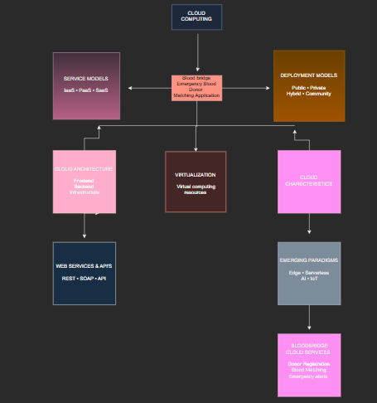

Brief explanation of your concept map: explain the most important nodes, link labels, hierarchy, and capstone connection.
The concept map explains the relationship between the BloodBridge: Emergency Blood Donor Matching Application and the major concepts of cloud computing. The central node is BloodBridge, which is connected to cloud computing fundamentals such as cloud definition, cloud evolution, cloud architecture, service models, deployment models, virtualization, web services, APIs, and cloud characteristics. The link labels such as uses, supports, communicates through, provides, and enables show how each cloud concept contributes to the application. The hierarchy begins with cloud computing fundamentals, followed by architecture and service models, then cloud characteristics and emerging paradigms, and finally connects to BloodBridge cloud services like donor registration, blood requests, location-based matching, and emergency notifications. This concept map demonstrates how cloud technologies provide scalability, elasticity, security, and reliable data storage for the BloodBridge application.

Task 2 - Service Model Matrix
Complete the matrices by making technical decisions for your capstone project. Select only the rows that are relevant to your capstone design. If a row is not used, write a short technical reason instead of leaving it blank.
Your answer should show how responsibility shifts between cloud provider and student development team, and how the chosen services support the capstone workflow, API design, storage, security, scalability, and evidence submission.

Task 2A - Service Model Responsibility Matrix
Service Model | Capstone Role / Module | Provider Responsibility | Student Responsibility | Evidence to Submit
IaaS | Service Model | Capstone Role / Module | Provider Responsibility | Student Responsibility
PaaS | IaaS | Virtual server and cloud infrastructure | Provides virtual machines, networking, storage, and security | Configure servers and deploy the BloodBridge application
SaaS | PaaS | Backend application and API hosting | Provides runtime environment, database services, and development platform | Develop backend logic, APIs, and donor matching system
XaaS / Specialized Service | SaaS | BloodBridge web/mobile application | Hosts and delivers the application to users | Design user interface and manage application features

Task 2B - Capstone Cloud Service Decision Matrix
Cloud Layer / Function | Selected Tool or Service | Data / Resource Handled | API or Integration Path | Security / Scaling Note
Client access and UI | Cloud Layer / Function | Selected Tool or Service | Data / Resource Handled | API or Integration Path
API / backend logic | Client Access and UI | BloodBridge Mobile App / Web App | User requests, donor registration | HTTPS REST API
Authentication and identity | API / Backend Logic | Google Cloud Run / AWS EC2 | Blood request processing | REST API
Database / structured records | Authentication and Identity | Firebase Authentication | User credentials | Authentication API
File / object storage | Database / Structured Records | Firebase Firestore / MySQL | Donor records, hospitals, requests | Database API
Monitoring / logs / usage metrics | File / Object Storage | Firebase Storage / Amazon S3 | Profile images and documents | Storage API
Analytics / reporting output | Monitoring / Logs / Usage Metrics | Google Cloud Monitoring / AWS CloudWatch | Performance logs | Monitoring API
Technical justification: Explain why the selected cloud service pattern fits your capstone project's users, data, API flow, scalability, and security needs.
The selected cloud service pattern is suitable for the BloodBridge project because it provides reliable, secure, and scalable cloud infrastructure for handling emergency blood requests. IaaS supplies the virtual infrastructure required to host the application. PaaS simplifies backend development and deployment by providing managed services for application logic and databases. SaaS enables users to access the BloodBridge application through a web browser or mobile device without installing additional software. XaaS services such as authentication, cloud monitoring, and notifications improve application security, performance, and user experience. Cloud databases securely store donor information, while REST APIs enable communication between the frontend, backend, and cloud services. Auto scaling and load balancing ensure that the application can handle a large number of users during emergencies without affecting performance

Task 3 - Capstone Cloud Flow Mapping
Study the sample architecture-flow template below. Redraw it in draw.io / diagrams.net using your own capstone architecture. Replace every generic label with your actual user role, screen, API endpoint, backend logic, cloud storage, analytics output, security control, and scalability or elasticity decision.
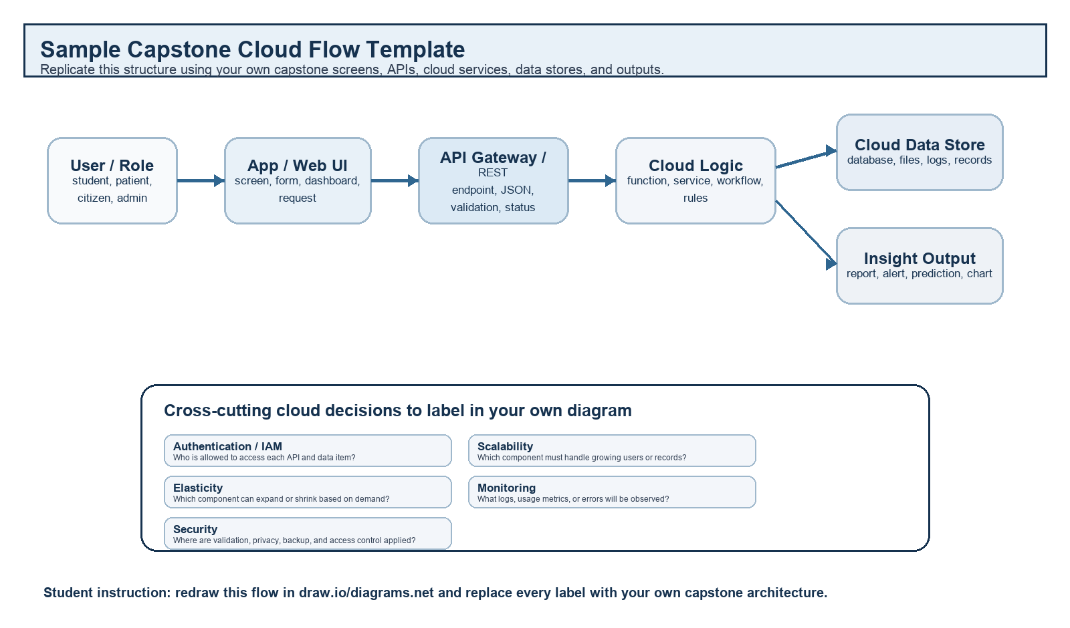
Student Drawing Requirement
Do not copy the sample as it is. Use it as a layout model, then create your own capstone-specific flow diagram with meaningful labels, arrows, data movement, API names, and cloud service choices.
Flow Component | Student Entry
Flow Component | Student Entry
User role and action | Patient or Hospital submits an emergency blood request through the BloodBridge application.
Frontend / app screen | Blood Request Screen where the user enters blood group, units required, hospital, and location.
API endpoint and method | POST /api/v1/blood/request
Backend processing rule | The server validates the user, verifies the request, searches the cloud database for matching donors, and generates the response.
Cloud database / storage operation | Stores donor details, patient requests, hospital information, and request history in the cloud database.
Response, alert, report, or dashboard output | Displays matching donors and sends emergency notifications to eligible donors. The administrator dashboard shows request statistics and donor activity.
Paste your redrawn capstone cloud-flow diagram here.



Brief explanation: explain one complete request-response path from user action to cloud response.
When a patient or hospital submits an emergency blood request through the BloodBridge application, the request is securely sent to the API Gateway using HTTPS. The Authentication Service verifies the user's identity before forwarding the request to the backend server. The backend searches the cloud database for compatible blood donors based on blood group and location. If matching donors are found, emergency notifications are sent through the notification service, and the donor list is displayed to the user. The application uses auto scaling and load balancing to maintain high performance during periods of heavy demand, while monitoring services continuously track system health and performance.

Task 4 - Individual Reflection
Answer the following from your own perspective. Avoid team-common wording.
- What is the strongest cloud concept represented in your capstone project?
users and emergency blood requests at the same time. Cloud computing allows the application to increase resources automatically when demand grows, ensuring reliable performance.

- Where will elasticity or scalability become important in your capstone product?
Elasticity and scalability become important during emergencies, natural disasters, or blood donation campaigns when many users access the application simultaneously. Cloud auto scaling ensures that the system can handle increased traffic without slowing down or becoming unavailable.

- Which API or web-service idea is most relevant to your project and why?
The most relevant web-service technology is the REST API. REST APIs enable secure communication between the BloodBridge mobile application, backend server, cloud database, and notification services. They are lightweight, fast, and easy to integrate with different cloud platforms.

- What did you personally understand better after preparing this concept map and matrix?
After preparing this concept map and service model matrix, I gained a better understanding of how cloud computing concepts such as service models, deployment models, virtualization, APIs, scalability, elasticity, and cloud architecture work together to build a real-world application. I also learned how different cloud services support secure, reliable, and scalable application development.
After preparing this concept map and service model matrix, I gained a better understanding of how cloud computing concepts such as service models, deployment models, virtualization, APIs, scalability, elasticity, and cloud architecture work together to build a real-world application. I also learned how different cloud services support secure, reliable, and scalable application development.

Evaluation Rubric - 100 Marks
Criteria | Marks | Expected Standard
Concept identification | 20 | Major CO1 concepts are accurately identified: cloud fundamentals, characteristics, evolution, service models, deployment models, virtualization, web services, SOAP/REST, APIs, elasticity, and scalability.
Relationship mapping | 20 | Links between concepts are accurate, meaningful, and labeled. The map should explain how concepts depend on, enable, consume, provide, scale, or control one another.
Hierarchy and organization | 15 | Concepts are arranged in a logical hierarchy with clear grouping, readable flow, and no disconnected keyword clusters.
Technical relevance | 15 | The map strongly reflects cloud course content and avoids decorative or generic non-technical content.
Service model matrix | 15 | IaaS, PaaS, SaaS, and XaaS are compared with provider responsibility, user responsibility, examples, capstone usage, and risks or limitations.
Capstone alignment and individual reflection | 10 | The student's own capstone interpretation is visible in the concept map, flow mapping, justification, and reflection. Team-common answers are avoided.
Visual clarity and digital evidence | 5 | Diagram is neat, readable, exported properly, and supported with GitHub evidence including source and exported files.

Faculty Evaluation Record
Evaluator Name |  | Marks Awarded
Observation |  | Signature

